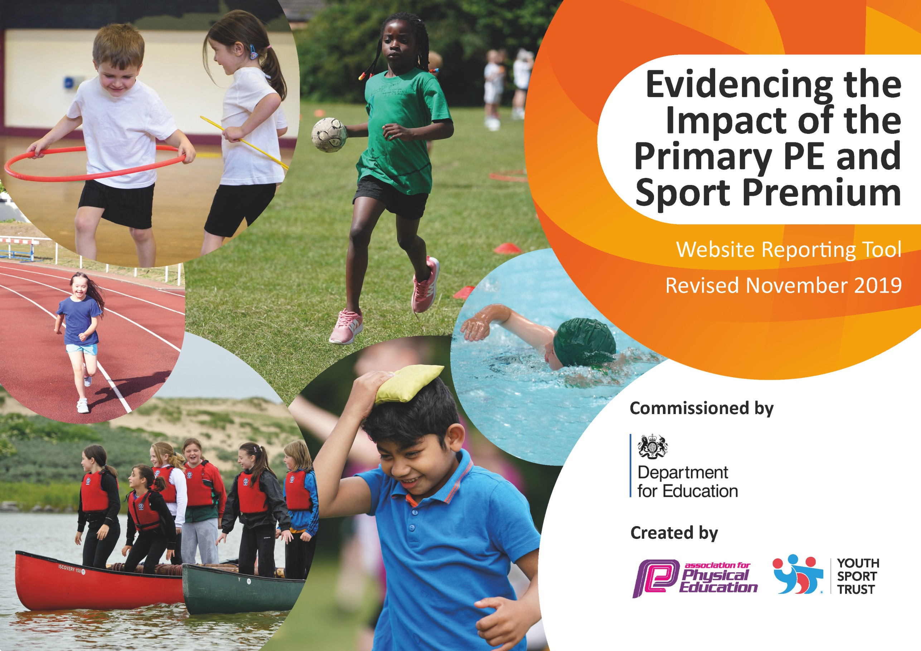
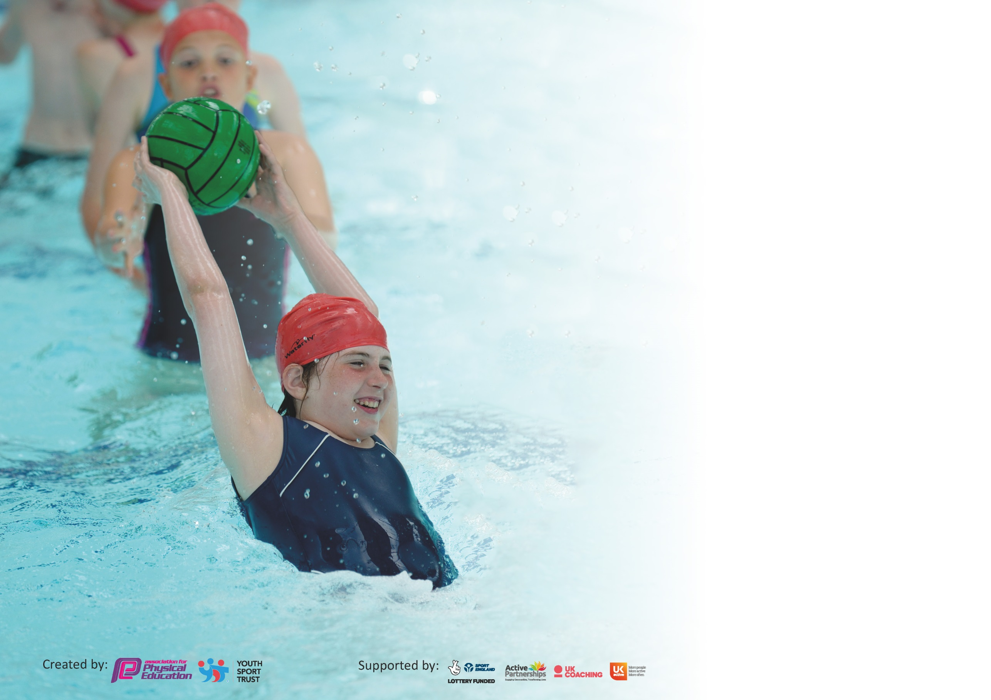

It is important that your grant is used effectively and based on school need. The Education Inspection Framework (Ofsted 2019 p64) makes clear there will be a focus on ‘whether leaders and those responsible for governors all understand their respective roles and perform these in a way that enhances the effectiveness of the school’.

Under the Quality of Education criteria (p41) inspectors consider the extent to which schools can articulate their curriculum (INTENT), construct their curriculum (IMPLEMENTATION) and demonstrate the outcomes which result (IMPACT).

To assist schools with common transferable language this template has been developed to utilise the same three headings which should make your plans easily transferable between working documents.

Schools must use the funding to make additional and sustainable improvements to the quality of Physical Education, School Sport and Physical Activity (PESSPA) they offer. This means that you should
use the Primary PE and Sport Premium to:

- Develop or add to the PESSPA activities that your school already offer
- Build capacity and capability within the school to ensure that improvements made now will benefit pupils joining the school in future years

Please visit gov.uk for the revised DfE guidance including the 5 key indicators across which schools should demonstrate an improvement. This document will help you to review your provision and to report your spend. DfE encourages schools to use this template as an effective way of meeting the reporting requirements of the Primary PE and Sport Premium.

We recommend you start by reflecting on the impact of current provision and reviewing the previous spend.

Schools are required to publish details of how they spend this funding as well as on the impact it has on pupils’ PE and sport participation and attainment by the end of the summer term or by 31st July 2020 at the latest.

We recommend regularly updating the table and publishing it on your website throughout the year. This evidences your ongoing self-evaluation of how you are using the funding to secure maximum, sustainable impact. Final copy must be posted on your website by the end of the academic year and no later than the 31st July 2020. To see an example of how to complete the table please click HERE.

Support for review and reflection - considering the 5 key indicators from DfE, what development needs are a priority for your setting and your pupils now and why? Use the space below to reflect on previous spend and key achievements and areas for development.

Key achievements to date until July 2019: | Areas for further improvement and baseline evidence of need:
- Improve regularity of PE Kit.
- More intra school competitions, especially in light of the potential restrictions for Covid-19. Set up personal best competitions and encourage regular competition within PE Lessons.

Meeting national curriculum requirements for swimming and water safety.
What percentage of your current Year 6 cohort swim competently, confidently and proficiently over a distance of at least 25 metres?  N.B. Even though your pupils may swim in another year please report on their attainment on leaving  primary school at the end of the summer term 2020. | 84%
What percentage of your current Year 6 cohort use a range of strokes effectively [for example, front crawl, backstroke and breaststroke]? | 26%
What percentage of your current Year 6 cohort perform safe self-rescue in different water-based situations? | 51%
Schools can choose to use the Primary PE and Sport Premium to provide additional provision for swimming but this must be for activity over and above the national curriculum requirements. Have you used it in this way? | No

Action Plan and Budget Tracking
Capture your intended annual spend against the 5 key indicators. Clarify the success criteria and evidence of impact that you intend to measure to evaluate for pupils today and for the future.

Academic Year: 2019/20 | Total fund allocated: £10,691 | Date Updated: 15/07/20
Key indicator 1: The engagement of all pupils in regular physical activity – Chief Medical Officer guidelines recommend that primary school pupils undertake at least 30 minutes of physical activity a day in school |  |  |  | Percentage of total allocation:
 |  |  |  | %
Intent | Implementation |  | Impact
Your school focus should be clear what you want the pupils to know and be able to do and about  what they need to learn and to  consolidate through practice: | Make sure your actions to achieve are linked to your intentions: | Funding allocated: | Evidence of impact: what do pupils now know and what can they now do? What has changed?: | Sustainability and suggested next steps:
Continuation / extension of established successful programme of change for life, breakfast, lunchtime and after school activities. With the addition of more physical activity within lessons and during school in the form of the Daily Mile. |  |  | Children fully engaged at lunchtimes in a range of activities.  Numbers from ASC registers.  Feedback from Children and Adults. (Unable to gather due to Covid) | Continue to use Daily Mile to increase PA levels.  Continue to promote PA and benefits of an active school population.
Key indicator 2: The profile of PESSPA being raised across the school as a tool for whole school improvement |  |  |  | Percentage of total allocation:
 |  |  |  | %
Intent | Implementation |  | Impact
Your school focus should be clear what you want the pupils to know and be able to do and about  what they need to learn and to  consolidate through practice: | Make sure your actions to achieve are linked to your intentions: | Funding allocated: | Evidence of impact: what do pupils now know and what can they now do? What has changed?: | Sustainability and suggested next steps:
Using PE as a vehicle to be at the heart of British Values, supporting the whole school ethos. Whole school approach to PE & Swimming, and engagement in Physical Activity. | Sports Leaders (Crew) new leaders to be trained to support intra school sports comps / lunchtimes/Before School. Sports leaders to develop in school competitions and assist with the delivery of sports day and fitness club.  All certificates for sporting achievements to be handed out during celebration assemblies.  Sportsman/woman of the year to be nominated and awarded to the outgoing year 6 children.  Display all competition events on sports notice board and regularly update the sports blog. |  | Number of children regularly wearing appropriate PE kit.  Continue to celebrate schools success within sports.  Achieve school games Gold Mark. | Maintain high standards within PESSP, ensure young leaders are developed year on year.  Use young Leaders to develop a range of playground games/challenges to create additional competitive opportunities.

Key indicator 3: Increased confidence, knowledge and skills of all staff in teaching PE and sport |  |  |  | Percentage of total allocation:
 |  |  |  | %
Intent | Implementation |  | Impact
Your school focus should be clear | Make sure your actions to | Funding | Evidence of impact: what do | Sustainability and suggested
what you want the pupils to know | achieve are linked to your | allocated: | pupils now know and what | next steps:
and be able to do and about | intentions: |  | can they now do? What has
what they need to learn and to |  |  | changed?:
consolidate through practice:
Continue to support staff confidence, competence and subject knowledge through CPD and improved access to resources. | Re-new license for PE Passport planning and assessment tool  Continue to audit and replenish PE equipment, using the sports leaders and staff to identify need for new equipment.  Manchester City to deliver curriculum sessions 1 day per week in EYFS/Y1-Y6 to increase staff Knowledge & Confidence within PE.  Send all NQT’s (5) on relevant CPD | £300 (PE Passport)  (£515)  (£6,000)  (£900) | License for PE Passport has been renewed. This allows teachers in all years to have access to a range of planning that link directly from the curriculum and aims to improve children's physical literacy from EYFS to Year 6.  NQT's have attended PE CPD courses. | Extend knowledge and understanding by continuing to train staff using the App.  Subject leader to have time to team teach and observe. Teachers will also benefit from observing in MCFC sessions.
Key indicator 4: Broader experience of a range of sports and activities offered to all pupils |  |  |  | Percentage of total allocation:
 |  |  |  | %
Intent | Implementation |  | Impact
Your school focus should be clear | Make sure your actions to | Funding | Evidence of impact: what do | Sustainability and suggested
what you want the pupils to know | achieve are linked to your | allocated: | pupils now know and what | next steps:
and be able to do and about | intentions: |  | can they now do? What has
what they need to learn and to |  |  | changed?:
consolidate through practice:
Continue the successful programme of extra-curricular activities and develop for specific groups (SEND/G&T). Allow children to experience a range of different activities. | Investment made into an Outdoor Learning resource. To assisit with the delivery of OAA and also develop greater links within the wider curriculum. Particularly geography. | (£730 Enrich Education) | Supplied and installed shortly before school closure in March. | Introduce to staff, begin using across school September 20.

Key indicator 5: Increased participation in competitive sport |  |  |  | Percentage of total allocation:
 |  |  |  | %
Intent | Implementation |  | Impact
Your school focus should be clear | Make sure your actions to | Funding | Evidence of impact: what do | Sustainability and suggested
what you want the pupils to know | achieve are linked to your | allocated: | pupils now know and what | next steps:
and be able to do and about | intentions: |  | can they now do? What has
what they need to learn and to |  |  | changed?:
consolidate through practice:
Continue to engage / expand fully with School Games competitions and develop intra school competitions. Promote local clubs allowing pathways for all children. | School will continue to use the school budget to pay for additional hours to attend competitions, the running of the school mini bus & Taxis, coaches to support G & T practices and purchasing of equipment needed for competitions including inclusion activities. | (£200 taxis) | Award of School Games Award (Gold) 2 years running. | Let children know about their local clubs as part of a display.  Continued development of MAT competition calendar to include Rugby and Inclusion for 19/20.  Increase number of Intra-School competitions in light of Covid-19 restrictions.

Signed off by
Head Teacher: | Steve Wheeldon
Date:
Subject Leader: | Pat Eccles
Date: | 15.07.20
Governor:
Date:

